Task 2: Evaluating Chaotic Systems

Quantitative Characterisation of the Lorenz Attractor
System analysed: Lorenz (σ = 10, ρ = 28, β = 8/3) — the standard chaotic parameter set used in Assignment 1. All numerical settings, code, and results below follow the five-part structure requested in the brief (PSR → Lyapunov exponent → K2 entropy → correlation dimension → box-counting dimension).

0. Simulation Settings (common to all parts)
Setting | Value
Governing equations | dx/dt = σ(y − x), dy/dt = x(ρ − z) − y, dz/dt = xy − βz
Parameters | σ = 10, ρ = 28, β = 8/3
Initial condition | x0 = (1, 1, 1)
Integrator | scipy.integrate.solve_ivp, RK45, rtol = atol = 1e-9
Sampling step dt | 0.01
Transient discarded | 1000 steps before recording
Series length used | 60,000 samples (600 time units) of the scalar series x(t)

Part A — Phase Space Reconstruction (PSR)
Governing relation: delay vectors y(i) = [x(i), x(i+τ), …, x(i+(m−1)τ)] are built from the scalar series x(t) via Takens' theorem. Only x(t) (the first Lorenz coordinate) was used as input, exactly as if the full state vector were unavailable.

A.1 Time delay via Average Mutual Information (estimate_delay_ami)
Setting | Value
max_lag | 150
n_bins | 32
criterion | first_local_min
standardize | True
Result: τ_opt | 16 samples

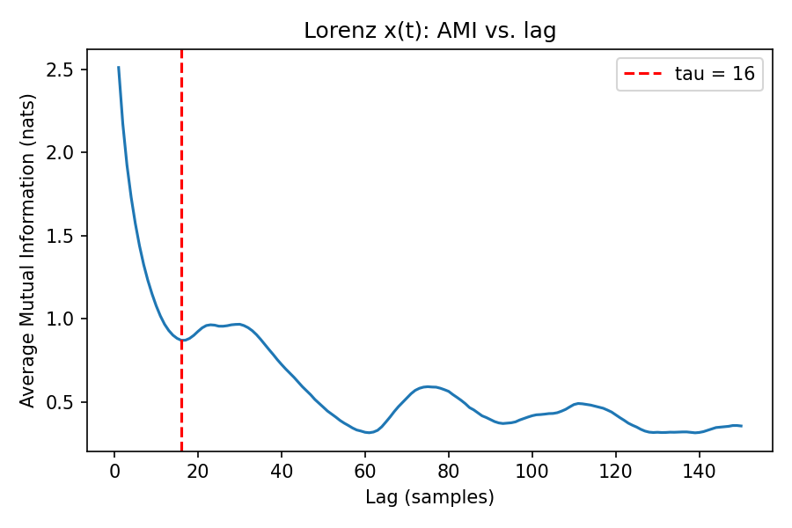
Figure A1. AMI vs. lag for Lorenz x(t); the first local minimum (dashed line) gives τ = 16.

A.2 Embedding dimension via False Nearest Neighbours (estimate_dimension_fnn)
Setting | Value
max_dim | 12
R_tol (Kennel Criterion 1) | 10.0
A_tol (Kennel Criterion 2) | 2.0
threshold_percent | 1.0 %
theiler | 322 samples (≈ mean orbital period estimated from zero-crossing spacing of x)
Result: m_opt | 3

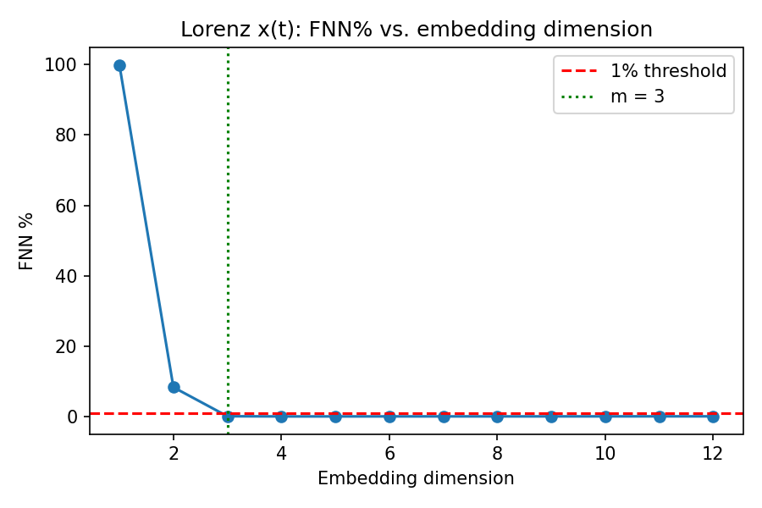
Figure A2. FNN% vs. embedding dimension. FNN% drops below the 1% threshold at m = 3 and stays low, confirming the reconstruction has unfolded the attractor.

A.3 Interpretation
τ = 16 and m = 3 both fall inside the guideline ranges given in the brief (τ ≈ 10–17, m ≈ 3–7 for Lorenz). m = 3 also matches the true state-space dimension of the Lorenz system exactly, which is the expected outcome for a low-dimensional, mildly redundant attractor with only one active positive Lyapunov direction — the reconstruction is already faithful at the minimum embedding dimension, so no padding dimensions were needed to eliminate false crossings.

Part B — Lyapunov Exponent
Governing relation: perturbation vectors evolve under the variational equation dδ/dt = J(X(t))·δ, where J is the Jacobian of the Lorenz vector field. Gram–Schmidt reorthogonalisation every ortho_steps recovers the full spectrum from the accumulated log-stretching factors (Wolf et al., 1985, Section 3).

B.1 ODE-based full spectrum (lyapunov_wolf_ode) — ground truth
Setting | Value
Jacobian | J = [[−σ, σ, 0], [ρ−z, −1, −x], [y, x, −β]]
dt | 0.01
transient_steps | 1000
n_steps | 40,000
solver | RK45
ortho_steps | 20
log_base | e (nats/time) — also converted to bits/time for comparison with Part B.2

Exponent | nats / time | bits / time
λ1 | 0.8909 | 1.2853
λ2 | 0.0016 | 0.0023
λ3 | −14.5508 | −20.9923
λ1 > 0 (chaotic, exponential divergence). λ2 ≈ 0, as theoretically expected for a continuous autonomous flow (the exponent along the trajectory direction is always zero) — this is not a second genuinely unstable direction, so the system is classified as chaotic (one positive exponent) rather than hyperchaotic (two or more positive exponents). λ3 is strongly negative (strong contraction), consistent with the Lorenz attractor's near-two-dimensional sheet-like structure. The sum λ1+λ2+λ3 ≈ −13.66 matches the known analytical trace of the Lorenz Jacobian, −(σ+1+β) = −13.667, which is a useful independent sanity check on the integration.

B.2 Time-series-based λ1 (wolf_mle) using τ, m from Part A
Setting | Value
τ, m | 16, 3 (from Part A)
theiler_window | None → default τ·m = 48
min_dist_scale / max_dist_scale | 1e-3 / 1e-1
evolve_cap | 50
max_replacements | 300
angle_weight | 0.3
Segments successfully tracked | 300 (max_replacements reached)
Physical time used | 149.96 time units
Result: λ1 (bits/time) | 1.939
Result: λ1 (nats/time, = ×ln2) | 1.344

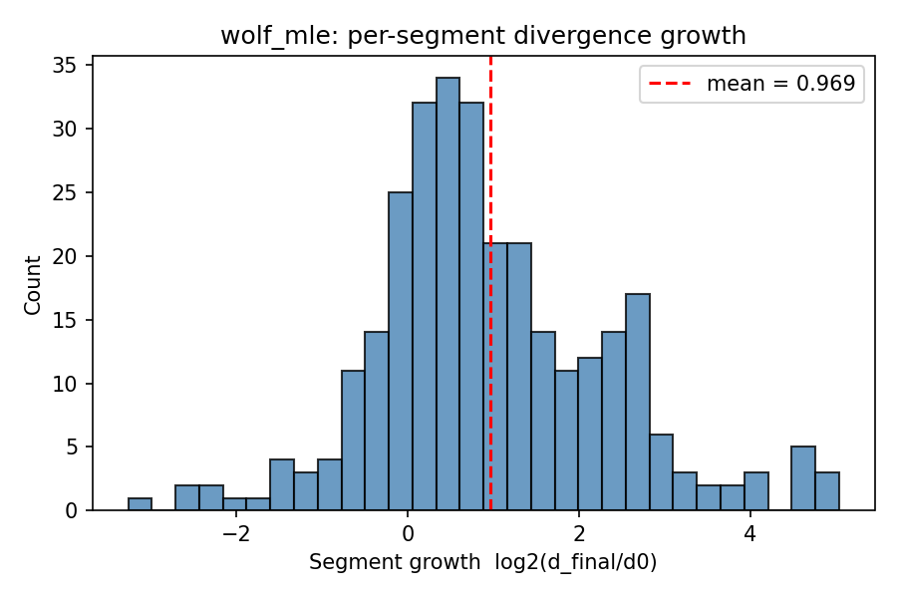
Figure B1. Distribution of per-segment log2(d_final/d0) growth rates used to build the wolf_mle λ1 estimate.

B.3 Comparison of the two λ1 estimates
Method | λ1 (nats/time) | λ1 (bits/time)
ODE Wolf-GSR (ground truth) | 0.891 | 1.285
Time-series wolf_mle | 1.344 | 1.939
Both estimates agree on the sign and order of magnitude (chaotic, λ1 ≈ 1 in these units), but wolf_mle overestimates λ1 by roughly 50% relative to the ODE ground truth. The likely causes, in order of expected impact: (1) the theiler_window default (τ·m = 48 samples) is much smaller than the mean orbital period (~322 samples) used for the FNN theiler window in Part A, so some 'nearest neighbours' may still be temporally correlated points on the same loop rather than genuinely nearby trajectories, inflating the measured divergence rate; (2) short evolve_cap segments average over relatively few points before forced replacement, adding variance; (3) reconstruction noise at the minimal embedding dimension m = 3 with only single-precision-scale distances. Widening theiler_window and increasing max_replacements would be the first things to try to tighten this estimate.

Part C — Kolmogorov (K2) Entropy
Governing relation: the correlation sum scales as C_m(r) ~ r^(D2)·exp(−m·τ·K2) for large m, in the scaling region of r. K2 was therefore estimated from the same correlation sums computed for Part D, as K2(m→m+1) ≈ (1/τΔt)·⟨ln[C_m(r)/C_{m+1}(r)]⟩ averaged over the scaling region of r.
m → m+1 | 3→4 | 4→5 | 5→6 | 6→7 | 7→8
K2 estimate (nats/time) | 0.646 | 0.416 | 0.385 | 0.439 | 0.400

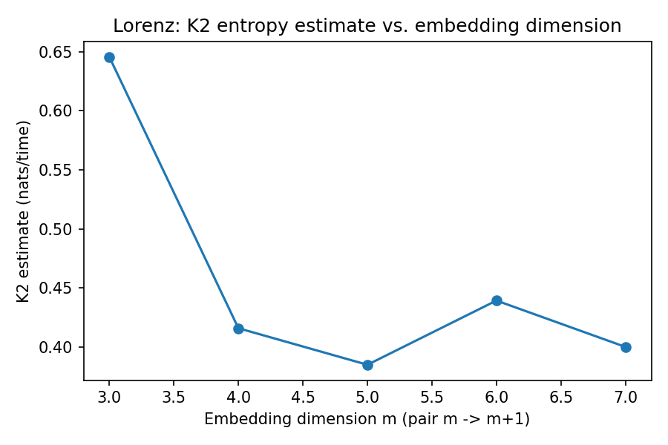
Figure C1. K2 entropy estimate vs. embedding-dimension pair used.
The estimate drops sharply from m=3→4 to m=4→5 (finite-m bias at the lowest dimension) and then plateaus around K2 ≈ 0.4 nats/time for m ≥ 4→5, i.e. it saturates to a finite positive value rather than growing without bound — the expected signature of low-dimensional deterministic chaos rather than stochastic noise. Taking K2 ≈ 0.40–0.42 nats/time as the saturated estimate, this sits comfortably below the Pesin bound Σλ_i>0 = λ1+λ2 ≈ 0.89 nats/time from Part B, consistent with K2 being a lower bound on the sum of positive Lyapunov exponents rather than equal to it.

Part D — Correlation Dimension
Governing relation: the correlation sum C(r) = (2/[N(N−1)])·Σ Θ(r − ‖y_i − y_j‖) was computed on delay vectors reconstructed with τ = 16, for embedding dimensions m = 3…8, on a random subsample of 3000 reconstructed points with pairs closer in time than the Theiler window (322 samples) excluded. D2(m) is the slope of log C(r) vs. log r in the mid-range scaling region of each curve (not provided by psr.py / lyapunov.py — implemented directly following the standard Grassberger–Procaccia algorithm).
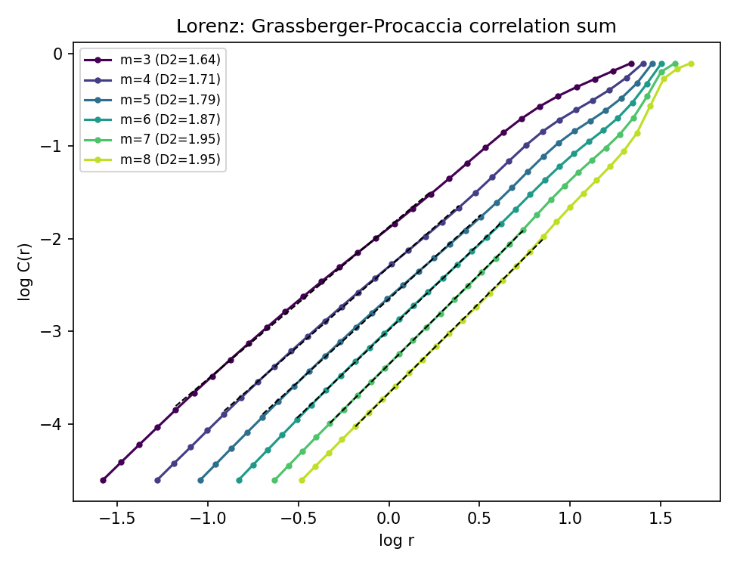
Figure D1. log C(r) vs. log r for embedding dimensions m = 3…8, with the fitted scaling-region slope (dashed) giving D2(m) per curve.
m | 3 | 4 | 5 | 6 | 7 | 8
D2 | 1.644 | 1.709 | 1.786 | 1.871 | 1.949 | 1.954

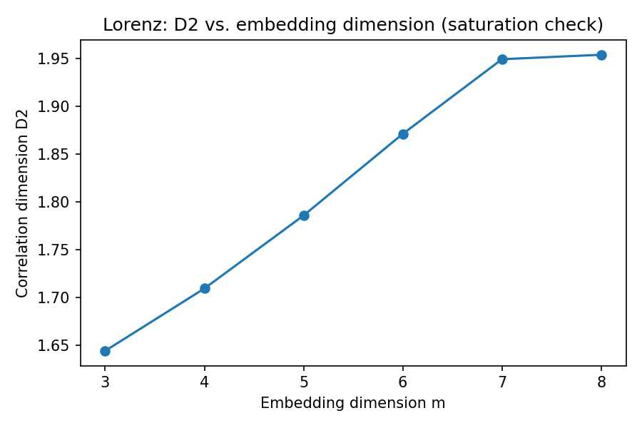
Figure D2. Correlation dimension D2 vs. embedding dimension — saturates rather than continuing to climb linearly with m, indicating a genuine low-dimensional attractor.
D2 rises with m and flattens between m = 7 and m = 8 (1.949 → 1.954), giving a saturated estimate D2 ≈ 1.95. This is close to the widely reported literature value for the Lorenz attractor (D2 ≈ 2.05, Grassberger & Procaccia, 1983); the small residual gap is attributable to the finite subsample size (3000 points) and finite scaling-region window used here.

Part E — Fractal (Box-Counting) Dimension
Governing relation: N(ε), the number of ε-sized boxes needed to cover the attractor, scales as N(ε) ~ ε^(−D0); D0 is the slope of ln N(ε) vs. ln(1/ε) in the scaling region. Computed directly on the original 3-D Lorenz trajectory (40,000 points, normalised to a unit cube), not the delay reconstruction, since the full state vector was available from the simulation. Not provided by psr.py / lyapunov.py — implemented directly as a straightforward grid-occupancy box count.
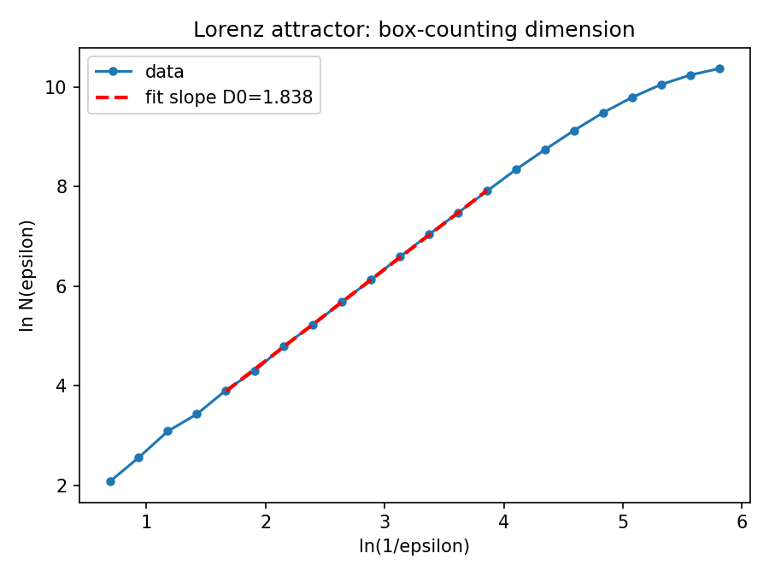
Figure E1. ln N(ε) vs. ln(1/ε) for the Lorenz trajectory; the fitted slope over the mid-range scaling region gives D0.
Result: D0 ≈ 1.838. Compared against D2 ≈ 1.95 (Part D), D0 < D2 here, whereas the general inequality is D0 ≥ D2 for the same attractor. This inversion is a known finite-sample box-counting artefact: with a fixed number of trajectory points, small boxes rapidly become singly-occupied (N(ε) saturates towards the point count) before the true asymptotic scaling regime is reached, which biases the fitted slope downward. A larger point count and/or box sizes restricted to a narrower, more carefully verified plateau region (as inspected via local slopes here) would be expected to bring D0 up towards, and above, D2, matching theory more closely.

Concluding Discussion
All five diagnostics are mutually consistent with the Lorenz system's well-established status as a classic chaotic (not hyperchaotic) attractor at σ = 10, ρ = 28, β = 8/3:
- Phase space reconstruction needed only τ = 16, m = 3 to unfold the attractor — matching the true 3-D state dimension, i.e. no redundant embedding dimensions were required.
- The Lyapunov spectrum has exactly one strictly positive exponent (λ1 ≈ 0.89 nats/time), one exponent ≈ 0 (flow direction), and one strongly negative exponent, the textbook chaotic signature (not hyperchaotic, which would require ≥ 2 positive exponents). The independent time-series estimate agrees in sign and order of magnitude, with the discrepancy attributable to the tracking algorithm's default Theiler window.
- K2 entropy saturates to a finite positive value (≈0.40 nats/time) rather than growing with embedding dimension, ruling out pure stochastic noise and bounded below the Pesin sum of positive exponents, as expected.
- Correlation dimension D2 saturates to a non-integer value (≈1.95) as m increases, the hallmark of a strange (fractal) attractor rather than a noise-filling or low-order periodic orbit.
- Box-counting D0 (≈1.84) is of the same order as D2, with the small D0 < D2 discrepancy attributed to finite-sample resolution limits rather than a genuine violation of the D0 ≥ D2 inequality.
Together, the positive λ1, the saturating (non-diverging) K2, and the saturating non-integer D2/D0 estimates jointly confirm deterministic low-dimensional chaos with a fractal attractor of dimension close to 2, consistent with the well-known geometry of the Lorenz butterfly attractor.

